CAR MODIFICATION BUSINESS WEBSITE
SPECIFICATIONS, INFORMATION DESIGN TAXONOMY, AND TECHNICAL BRIEF
- INTRODUCTION
This document outlines the website specifications, information design taxonomy, and technical brief for a car modification and maintenance business website. The website will function as an online platform where customers can learn about services, book maintenance or modification appointments, and purchase car parts through an online catalogue.
The platform aims to improve customer convenience, streamline workshop scheduling, and expand the business by allowing online parts ordering and service booking.
- PURPOSE OF THE WEBSITE
The primary purpose of the website is to provide an online system that allows customers to:
• View available car modification and maintenance services
• Book maintenance and modification appointments online
• Browse a catalogue of car parts and accessories
• Order car parts directly from the website
• Learn more about the company and its services
The website will also allow administrators to manage bookings, products, and customer orders efficiently.
- TARGET USERS
Primary Users
The main users of the website include:
• Car owners seeking maintenance services
• Car enthusiasts interested in performance upgrades
• Customers searching for car modification parts
Secondary Users
Secondary users include:
• Workshop mechanics and staff
• Website administrators who manage bookings and product listings
- WEBSITE FEATURES
4.2 Online Booking System
The website will provide an appointment booking system that allows customers to schedule maintenance or modification services.
Users will be able to:
• View available appointment dates
• Select a specific service
• Book a preferred date and time
• Receive booking confirmation
• Reschedule or cancel bookings if necessary
The booking form will collect the following information:
• Customer name
• Phone number
• Email address
• Vehicle make, model and registration
• Requested service
• Preferred booking date
• Additional notes or special requests
4.2 Car Parts Catalogue
The website will include a product catalogue that displays available car parts and accessories.
Customers will be able to:
- Browse available parts
- Search for specific products
- Filter products by category or vehicle type
- View product prices
- View detailed product descriptions
- Write and read reviews on the products
Each product page will display:
- Product name
- Product images
- Product price
- Detailed description
- Compatibility with vehicle types
- Availability status
- Product reviews
4.3 Online Ordering System
The platform will allow customers to purchase car parts directly from the website.
Customers will be able to:
• Add/remove products to a shopping cart
• View items in their cart
• Proceed to checkout
• Enter shipping or collection details
• Select a preferred payment method
Possible payment methods include:
• Card payments
• Mobile payments
• Bank transfers
• Pay on collection
4.4 Services Page
The services section will display all modification and maintenance services offered by the business.
Services include:
- Engine tuning
- Suspension upgrades
- Body kit installation
- Paint and wraps
- Exhaust system modifications
- Brake upgrades
- Vehicle maintenance
Each service page will include:
• Service description
• Pricing
• Service duration
4.5 User Accounts
The website may include optional user accounts that allow customers to create personal profiles.
Registered users will be able to:
- Make orders
- Track their orders
- Book vehicular services
- View booking history
- Save vehicle information for future bookings
- Manage their account details
4.6 Admin Dashboard
The website will include an administrative dashboard where business staff can manage website operations.
Administrators will be able to:
• Manage appointment bookings
• Add, update, or remove products from the catalogue
• Update product prices
• View and manage customer orders
• Manage user accounts
• Upload and manage product images
- INFORMATION DESIGN AND TAXONOMY
Information design refers to how content is structured and organized within the website to ensure easy navigation and user experience.
5.1 Main Navigation Structure
The main website navigation will include the following sections:
Home
Services
Parts Catalogue
Book Appointment
Shop / Cart
About Us
Contact
5.2 Services Categories
The services section will be divided into the following categories:
- Maintenance services
- Performance upgrades
- Exterior modifications
- Interior modifications
5.3 Parts Catalogue Categories
The product catalogue will be divided into the following categories:
- Engine parts
- Suspension systems
- Exhaust systems
- Wheels and tires
- Brake components
- Interior accessories
- Exterior accessories
5.4 Website Sitemap
Below is a table illustrating the website sitemap:
Home page


ABOUT US PAGE

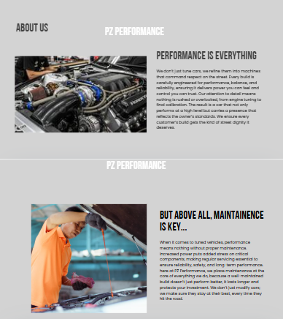

SERVICES PAGE
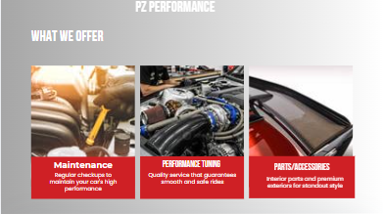

PARTS CATALOGUE
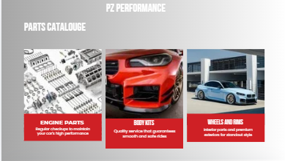
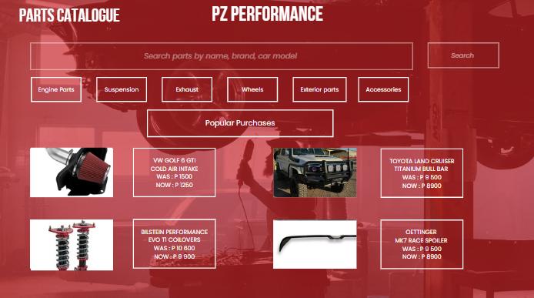

FEEDBACK
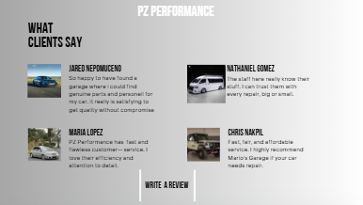

SHOP PAGE
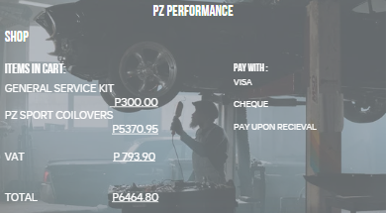
SIGN UP PAGE

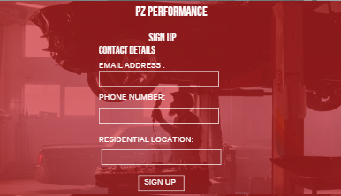

CONTACT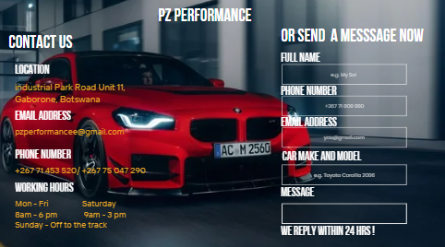

Home
Services | Parts Catalogue | Book Appointment | Shop | About Us | Contact
- Maintenance  - Engine Tuning  - Suspension Upgrades  - Body Modifications | - Engine Parts  - Suspension  - Exhaust  - Wheels  - Accessories |  | - Cart  - Checkout

5.5 Homepage Content Structure
The homepage will include the following sections:
Hero Section
This area will display branding, images of modified vehicles, and a call-to-action encouraging users to book services or explore parts.
Featured Services
A section highlighting the most popular modification services offered by the workshop.
Popular Products
A display of frequently purchased or featured car parts.
Quick Booking Section
A direct link or form allowing customers to quickly schedule appointments.
Customer Testimonials
Feedback from satisfied customers to build trust and credibility.
Contact Information
Business address, phone number, and operating hours.
- TECHNICAL BRIEF
The technical brief describes the technologies and system architecture required to build the website.
6.1 Development Platform Options
Custom Web Application
The website will be built as a custom web application. This approach provides greater flexibility and scalability.
Frontend Technologies
• HTML5
• CSS
• JavaScript
Backend Technologies
• Server-side programming for handling bookings and orders
Database System
• A structured database to store users, products, orders, and bookings
6.2 System Components
Frontend
The frontend is the user-facing part of the website that customers interact with. It includes:
• Homepage
• Services pages
• Product catalogue
• Booking forms
• Shopping cart and checkout pages
Backend
The backend processes all system operations including:
• Booking management
• Order processing
• Product management
• User authentication
Database
The website database will store important information including:
• Users
• Products
• Orders
• Bookings
• Services
6.3 Security Requirements
The website must implement several security measures to protect customer data and transactions.
These include:
• Secure login authentication
• Secure payment processing
• Protection against unauthorized access
6.4 Performance Requirements
The website should meet the following performance standards:
• Mobile responsive design
• Fast loading pages
• Optimized images and media
• Efficient product search functionality
6.5 System Integrations
The website may integrate with external systems such as:
• Payment gateways for online transactions
• Email notification systems for booking confirmations
• SMS alerts for appointment reminders
• Inventory management systems for tracking product availability
- Publishing & Promotion
The website is hosted using GitHub Pages, which is a free hosting service provided by GitHub for static websites. The project files (HTML, CSS, JavaScript, and assets) were uploaded to a GitHub repository and published directly from the repository branch.
Tools and Methods Used
- GitHub account (for repository hosting)
- GitHub Desktop / Git Bash (for uploading files)
- Visual Studio Code (for writing and editing code)
- GitHub Pages (for website hosting and deployment)
Steps Followed to Publish the Website
- A GitHub repository was created for the project.
- The website files were added to the local project folder.
- The project was pushed to GitHub using Git commands:
GitHub Pages was enabled by:
Going to the repository settings
Selecting Pages
Choosing the main branch as the source
Saving the settings
GitHub automatically generated a live link for the website.
Website Link

The published website can be accessed using the following link:
https://cse25-347.github.io/Katlego-cse25-347/

- CONCLUSION
The proposed website will provide a complete digital platform for the car modification business. It will enhance customer convenience by allowing online booking and parts ordering while improving internal management through an administrative dashboard.
The combination of service booking, parts catalogue, and e-commerce functionality will help the business expand its reach and improve customer engagement.
- Future modifications to the website
Add Educational Content
Position the site as a knowledge hub, not just a store.
- Guides like “Best mods for beginners” or “Stage 1 vs Stage 2 tuning.”
- Installation tutorials (articles or videos).
- Maintenance tips after modifications
- Car mod comparisons

Compatibility Checker
A big pain point is “Will this fit my car?”
- Add a tool where users input their car details and only see compatible parts.
- Highlight required supporting mods (e.g., “this turbo requires upgraded fuel injectors”).

